  Class time: 1 -2 class periods  Subjects: Biology, Anatomy and Physiology  Grade Level: Middle and High School  Materials:  - access to the internet  - horseshoe crab model or molts (if available)  - for Part C - Looking at the Compound Eye: molts of varying sizes, scissors and dissecting microscopes; optional: plastic mesh sunglasses or cut drinking straws | Eyes on the Prize: Horseshoe Crabs, Ommatidia and the Nobel Prize!  Developed by: Sharon Tatulli, The Wheeler School, Providence, RI

OVERVIEW: This activity involves students in an internet-based information gathering activity involving the location, structure and function of each of the horseshoe crab’s (HSC’s) ten “eyes.” Students will add the information they gather to a diagram of a HSC, identifying the location of each type of eye.

CONCEPTS:
- During its lifetime, the HSC utilizes ten different visual structures, including simple and compound eyes.
- These visual structures are used for a variety of purposes.
- Certain visual structures are only present and functional during early/juvenile stages of development.
- The ommatidium (plural ommatidia) is the functional unit of the HSC compound eye
- HSC ommatidia were used to determine how a visual image is transmitted to the brain and how lateral inhibition works
- Lateral inhibition allows organisms to visually distinguish borders between objects
- As a HSC continues to grow and molt, the number of ommatidia in the compound eyes increases.
- The simple eyes of the HSC (ocelli) are sensitive to UV light and enable the HSC to detect the amount of light available from the moon and stars, and thus adjust the sensitivity of its compound eyes to light for night vision.
LEARNING OBJECTIVES: Through this activity students will be able to:
- Identify the location of each of the HSC’s ten “eyes” (visual structures)
- Explain what each visual structure is used for
- Explain the importance of compound eyes and lateral inhibition

TEACHER PREPARATION/PROCEDURE

1. This activity can be introduced in several ways:
- Viewing a short (5 minute) video clip featuring Dr. Robert Barlow and the “crab cam:” www.youtube.com/watch?v=2SBOKcuVHDo&NR=1 This is well worth watching and could also fit nicely as a follow up to part B of this activity.
- Exploring the ERDG website vision page: www.horseshoecrab.org/anat/vision.html

2. Students should work in pairs to do research on line, complete the diagrams and answer the questions. Based on time available, each group can be assigned either all or several of the questions. Answers to questions can be shared/reviewed in a discussion format after all information has been gathered.

3. Molts or plastic models of HSCs can be used to help students locate visual structures.

4. Plastic mesh sunglasses can be used to illustrate what a HSC sees via its compound eye. Here is a link to where these inexpensive toys can be purchased ($13.50 per dozen): www.rinovelty.com/index.cfm/fuseaction/products.detail/item/SGMESGL/mesh_sunglasses Instead of seeing a mosaic or kaleidoscope series of images (as is often misreported), these glasses present a field of view that is essentially one image integrated from the many lenses at once. The same effect can be created by cutting several drinking straws into short pieces and binding them together, then looking through the ends. Many thanks to Dr. Elizabeth Cowles of Eastern Connecticut State College for pointing out this misconception and suggesting this approach to getting the concept right.

5. Note: Various internet and book sources differ in how they describe the HSC’s visual organs/structures. Some state that the HSC has ten eyes. Though the HSC has ten visual organs, not all are true eyes and not all are present and functional during every stage of development. The endoparietal and rudimentary lateral eyes are only present and functional during early stages of development. The “eyes” located on the telson (tail) and on the ventral surface of the HSC are actually primitive photoreceptor cells.

6. For Part C: Looking at the Compound Eye, each student group will need a HSC molt to cut up. It is best to have a variety of molt sizes/ages for the class. If molts are not available, this part of the activity can be skipped. Alternatively, if molts are in limited supply, the compound eye of one molt can be cut out and displayed on a dissecting microscope so that students can see the lenses of the individual ommatidia.
EXTENSION 1: Exploring lateral inhibition
After completing this activity, students can also view the following link on lateral inhibition: http://serendip.brynmawr.edu/bb/latinhib.html. This link discusses the biological reasons behind optical illusions. Pretty cool!

EVALUATION/ASSESSMENT: Please refer to student handout immediately following this page for several assessment tools:
- Part A: The Many Eyes of the Horseshoe Crab
Diagrams of dorsal and ventral sides of the HSC where students will mark locations of visual structures and record their function(s)
- Part B: The Amazing Eyes of Limulus polyphemus!
A series of structured questions to be answered using the internet sources provided.

RESOURCES/REFERENCES: See websites listed in the accompanying Student Handout.
Student Handout for Eyes on the Prize:
Horseshoe Crabs, Ommatidia and the Nobel Prize!

Horseshoe crabs (HSCs) have had more than a few moments in the spotlight during their long history on the earth! One of those moments involves the study of vision. Although scientists (and just about everyone else) knew that the eyes were responsible for vision, the exact mechanism for how a visual image is transmitted to the brain was a mystery until the 1930s. The model organism used in this ground-breaking research was Limulus polyphemus, the American horseshoe crab. Haldan Keffer Hartline was able to isolate and examine the activity of a single eye unit, called an ommatidium (pl. ommatidia), from the compound eye of a HSC. He was able to document the relaying of signals from the ommatidia to the brain. Hartline was awarded the Nobel Prize in Physiology or Medicine in 1967 for his work in determining how ommatida interact. This discovery enabled scientists to understand the mechanisms involved in the important process of lateral inhibition. Lateral inhibition is a visual mechanism that allows many organisms (including humans and all other vertebrates) to visually distinguish borders between objects and see patterns.

Research involving the functioning of HSC eyes continues to this day. Dr. Robert Barlow, a former student of Hartline’s, researched vision in HSCs and the influence of vision on behavior. He determined that the simple eyes of a HSC are sensitive to ultraviolet light and that this sensitivity increases at night. This “UV vision” is what enables the HSC to detect when it is a full moon, which has great significance in explaining the HSC’s spawning cycle.

In this activity, you will research the important contribution of the HSC to our understanding of vision as well as learn about the specific structure and function of each of the HSC’s special types of eyes.

PROCEDURE for Part A: The Many Eyes of the Horseshoe Crab

Draw a line to the location of each the HSC’’s ten visual organs/structures on the diagrams on the next two pages. Give the name of each “eye” and a brief description of what it is used for. The information for the HSC’s endoparietal eye is drawn in as an example.

The following web sites will help you determine eye locations and their specific functions:
http://www.dnr.state.md.us/education/horseshoecrab/anatomy.html#eyes

http://www.dnr.state.md.us/education/horseshoecrab/eyechart.html

http://www.horseshoecrab.org/anat/vision.html

http://www.mbl.edu/marine_org/images/animals/Limulus/vision/index.html
This link - from the Marine Biological Laboratory (MBL) website - provides an excellent overview of the structure and function of horseshoe crab eyes. Read through all three pages: How eyes work, Hartline and lateral inhibition, and Barlow and behavior.
The Many Eyes of the Horseshoe Crab: Dorsal View

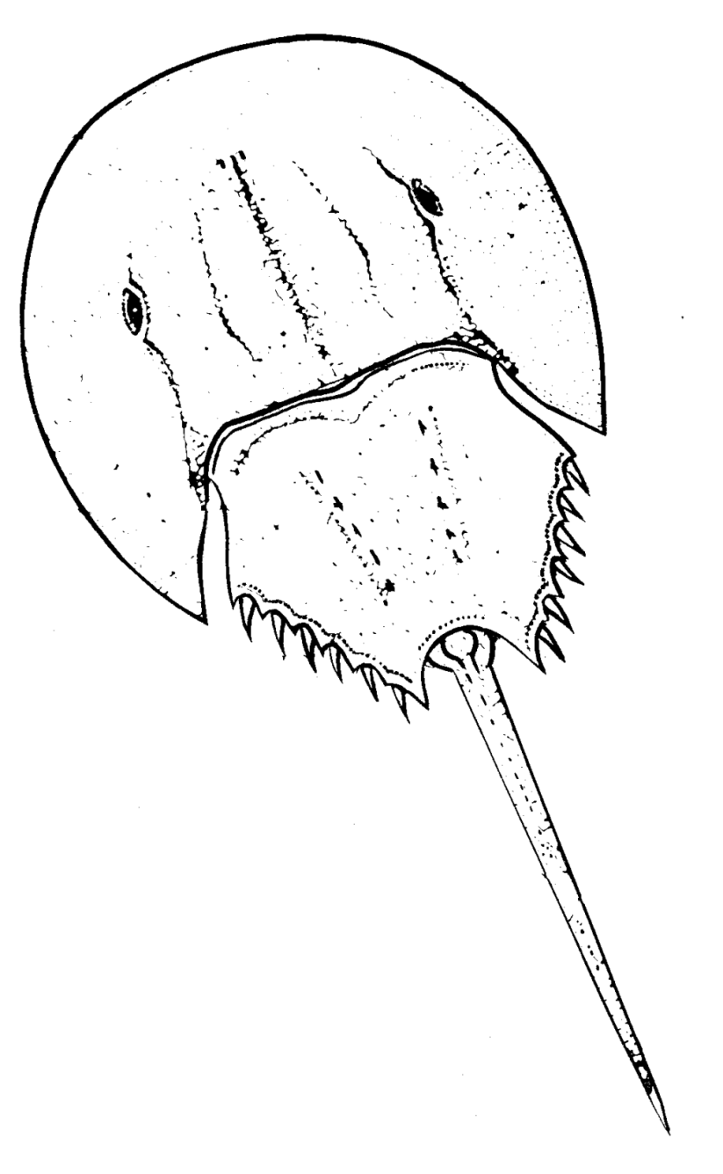
Endoparietal eye: is able to detect ultraviolet (UV) light from the sun and reflected light from the moon; involved in helping the horseshoe crab follow the lunar cycle; only visible and functional during early developmental stages

Illustration by Bob Jones

The Many Eyes of the Horseshoe Crab: Ventral View

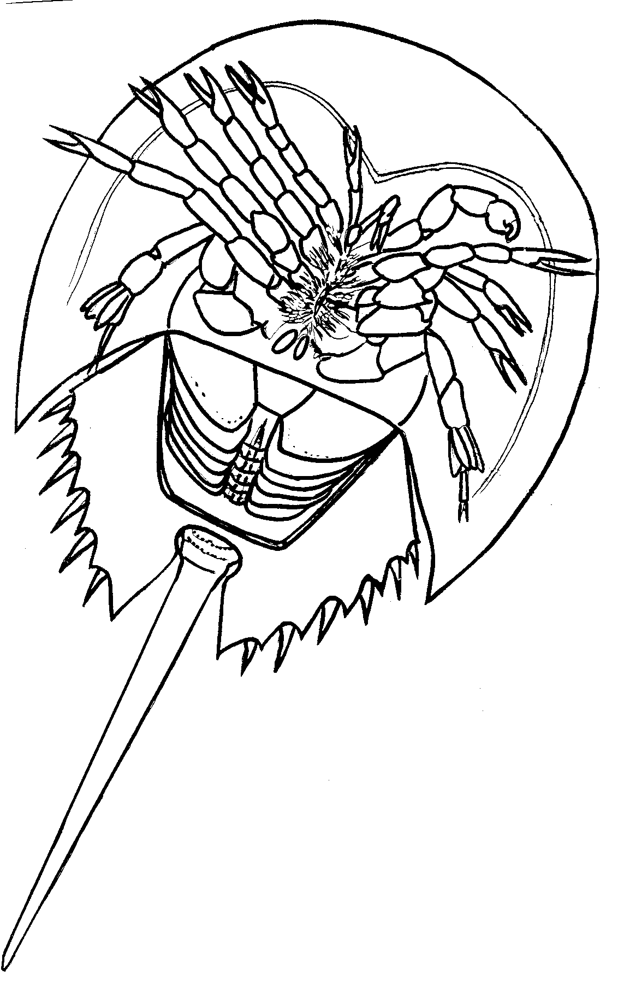

Illustration by Bob Jones
Part B. The Amazing Eyes of Limulus polyphemus!

Working with your partner answer the questions below, using the information you have already obtained and the websites to follow. Your teacher may ask you to answer some or all of these questions. You will share you answers with the rest of the class in a discussion.

How compound eyes work: http://courses.cit.cornell.edu/ent201/vision.html
http://askabiologist.asu.edu/explore/did-you-know-butterflies-are-legally-blind
http://www.physioviva.com/movies/ommatidium_struc-func/index.html

Horseshoe crab (HSC) vision: www.horseshoecrab.org/anat/vision.html
HSC eye research: www.ceoe.udel.edu/horseshoecrab/research/eye.html
How the HSC eye works: www.mbl.edu/marine_org/images/animals/Limulus/vision/index.html
HSC ommatidia: www.mbl.edu/marine_org/images/animals/Limulus/vision/hartline.html
Vision & behavior: www.mbl.edu/marine_org/images/animals/Limulus/vision/Barlow/index.html
Lateral inhibition: http://serendip.brynmawr.edu/bb/latinhib.html
Hartline: http://nobelprize.org/nobel_prizes/medicine/laureates/1967/hartline-bio.html

- Describe the structure of the compound eye of the horseshoe crab (HSC).

- What are ommatidia (singular: ommatidium)? Describe the structure of an ommatidium.

- Why was the HSC chosen as the model organism to research eye structure and function?

- What is lateral inhibition? Why is it important?

- How do ommatidia produce lateral inhibition?

- What did HSC eye researchers discover in 1960? Why was this discovery so significant?

- Ocelli (singular: ocellus) are simple eyes that are sensitive to UV light. Where are the ocelli located and how do they help the horseshoe crabs during the spawning season?

- What is the origin of the HSC’s Latin name, Limulus polyphemus?
Part C. Looking More Closely at the Compound Eye

1. When a HSC molts, it is shedding its exoskeleton. This includes the lenses of the ommatidia that make up the crab’s compound eyes. Working with your partner, take the HSC molt provided by your teacher and carefully cut around one of the compound eyes with a pair of scissors to remove the compound lens. Make your cuts about a half a centimeter from the eye, so that a little bit of additional exoskeleton is still attached.

2. Place the compound eye on the stage of a dissecting microscope and light the microscope from below. Focus in on the individual lenses of the ommatidia. As HSCs grow, each successive molt produces more ommatidia than the one before it.

3. Turn the compound eye over and focus the image. Compare what you see to the photos below. Does the inside surface of the individual ommatidia look different than the external surface? If so, describe the difference and hypothesize as to why that difference might exist.

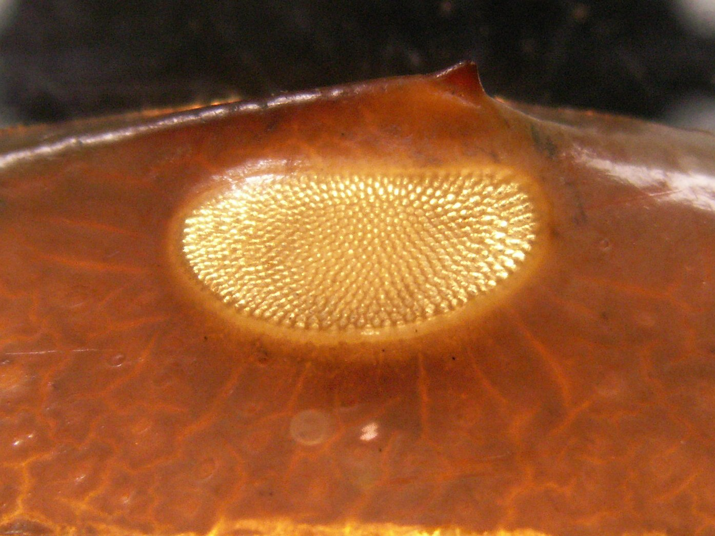  Photo above: magnified view of backlit HSC lateral eye. Right photos are further magnified views taken of the inside surface of the eyes, showing individual ommatidia. (all photographs courtesy of Anthony Jackson) | 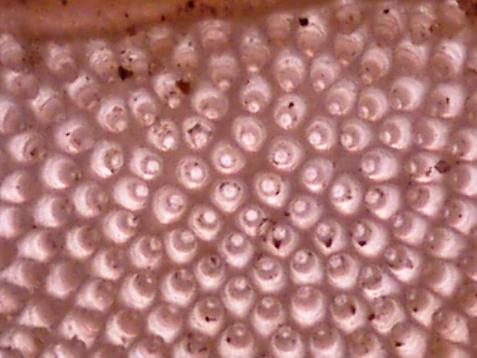
 | 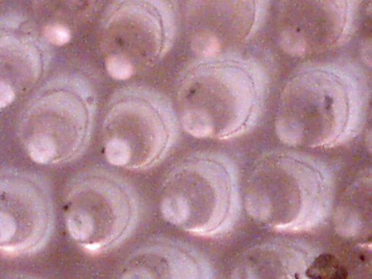

4. If your classmates are looking at compound eyes from molts of different sizes and ages than yours take a look under their dissecting scopes. Compare the number of ommatidia in your molt’s eye to that of your classmates. Are there fewer or more? Does the internal surface of the ommatidia look the same for eyes of different sizes?

5. Optional: look through the pair of plastic mesh sunglasses provided by your teacher. This simulates the view that a HSC has through its compound eyes. Describe how this view differs from what you see when you look at an object.
The Many Eyes of the Horseshoe Crab: Dorsal View Answer Key

Endoparietal eye: detect ultraviolet (UV) light from the sun and reflected light from the moon; involved in helping the horseshoe crab follow the lunar cycle; only visible and functional during early developmental stages.

Illustration by Bob Jones

Median eyes (ocelli): detect ultraviolet (UV) light from the sun and reflected light from the moon; involved in helping the horseshoe crab follow the lunar cycle. Enhance night vision according to the amount of UV light detected.
Compound (lateral) eyes: used primarily to find mates. At night, sensitivity to visible light is regulated by the median eyes (ocelli).
Rudimentary lateral eyes: photoreceptors that become active just before the embryo hatches. Not functional in adults.
Multiple Photoreceptors: scattered along the top and sides of the telson. Thought to synchronize the brain with the 24 hour light/dark cycle.

The Many Eyes of the Horseshoe Crab: Ventral View Answer Key

Ventral eyes: these two eyes may help orient the HSC while it is swimming

Illustration by Bob Jones

Part B. The Amazing Eyes of Limulus polyphemus! Answer Key

Working with your partner answer the questions below, using the information you have already obtained and the websites listed below. Your teacher may ask you to answer some or all of these questions. You will share you answers with the rest of the class in a discussion.

1. Describe the structure of the compound eye of the horseshoe crab (HSC).
In an adult HSC, the compound (also called “lateral”) eye is composed of approximately 1,000 smaller structures known as ommatidia.
2. What are ommatidia (singular: ommatidium)? Describe the structure of an ommatidium.
Ommatidia are the individual structures/units that make up the compound eye.
An ommatidium is composed of several parts:
- the cornea, which is formed from the exoskeleton and serves as a lens
- the crystalline cone, which acts as a second lens
- the retinula, which is a receptor unit that focuses the light on a translucent cylinder called the rhabdome.
- light-sensitive cells (retinular) cells surround the rhabdome and connect to axons of neurons. These neurons transport the visual signals to the HSC’s brain

3. Why was the HSC chosen as the model organism to research eye structure and function?
The HSC’s light-sensitive cells are 1000 times larger than the light sensitive cells (rods and cones) in humans and are similar in structure. The optic nerve of the HSC is up to four inches long and easy to access as it is located just below the upper surface of the prosomal exoskeleton. Also the HSC is large, easy to capture and work with, and can be safely kept out of water for several hours.
4. What is lateral inhibition? Why is it important?
Lateral inhibition is a process used by animals and humans to distinguish borders between objects. Visual receptors create a difference in perception (which is not actually there!), increasing contrast between objects and sharpening our vision.
5. How do ommatidia produce lateral inhibition?
Signals are produced by the light-sensitive cells in the ommatidia in response to exposure to light. These signals are transmitted by the axon to the optic nerve in the HSC’s brain. If one ommatidia is being stimulated by bright light and a neighboring ommatidium is receiving dim light, the first ommatidium inhibits the signal from the second. This results in further dimming of the dim signal which causes the perception of increased contrast. This allows the organism to more easily visually distinguish the borders between objects.
6. What did HSC eye researchers discover in 1960? Why was this discovery so significant?
H. Keffer Hartline won the 1967 Nobel Prize in Physiology or Medicine for his research involving HSC vision and the discovery of how lateral inhibition works.
Hartline’s research has led to greater understanding of human eye diseases like retinitis pigmentosa. This disease causes tunnel vision and can lead to total blindness.
7. Ocelli (singular: ocellus) are simple eyes that are sensitive to UV light. Where are the ocelli located and how do they help the horseshoe crabs during the spawning season?
The ocelli are located at the front of the prosoma. The functional ocelli in adults are the median eyes. The primary function of these eyes is to act as UV receptors that increase the sensitivity of the compound eyes. The sensitivity of the ocelli to UV light increases at night. In response to UV light, the ocelli send signals to the brain to suppress lateral inhibition, which in turn increases the sensitivity of the compound eyes, creating clearer images. The greatest amount of UV light is seen on full moon nights. Thus, the ocelli enable the male HSCs to more easily distinguish females from other objects.

8. What is the origin of the horseshoe crab’s Latin name, Limulus polyphemus?

Limulus: sidelong; polyphemus: Cyclops (single eye). Students can look up these words in an online dictionary if they miss the terms in the linked resources.

